**NAME : M . YOGAPPRIYA**

**REG.NO.: 820621106029**

**DEPARTMENT : ECE**

**YEAR: III**

**COLLEGE NAME: ARASU ENGINEERING COLLEGE**

**GROUP: IBM GROUP 4**

**NM ID : au820621106029**

***Market basket insights***

Market basket analysis is a data mining technique used by retailers to increase sales by better understanding customer purchasing patterns. It involves analyzing large data sets, such as purchase history, to reveal product groupings, as well as products that are likely to be purchased together.

The adoption of market basket analysis was aided by the advent of electronic point-of-sale (POS) systems. Compared to handwritten records kept by store owners, the digital records generated by POS systems made it easier for applications to process and analyze large volumes of purchase data.

Implementation of market basket analysis requires a background in statistics and data science, as well as some algorithmic computer programming skills. For those without the needed technical skills, commercial, off-the-shelf tools exist.

**Types of market basket insights**

Retailers should understand the following types of market basket analysis:

Predictive market basket analysis. This type considers items purchased in sequence to determine cross-sell.

Differential market basket analysis. This type considers data across different stores, as well as purchases from different customer groups during different times of the day, month or year. If a rule holds in one dimension, such as store, time period or customer group, but does not hold in the others, analysts can determine the factors responsible for the exception. These insights can lead to new product offers that drive higher sales.

**Algorithms for market basket insights**

In market basket analysis, association rules are used to predict the likelihood of products being purchased together. Association rules count the frequency of items that occur together, seeking to find associations that occur far more often than expected.

Algorithms that use association rules include AIS, SETM and Apriori. The Apriori algorithm is commonly cited by data scientists in research articles about market basket analysis and is used to identify frequent items in the database, then evaluate their frequency as the datasets are expanded to larger sizes.

The arules package for R is an open source toolkit for association mining using the R programming language. This package supports the Apriori algorithm, along with the following other mining algorithms:

1. arulesNBMiner

2.Opusminer

3.RKEEL

4.RSarules

**Examples of market basket insights**

Amazon's website uses a well-known example of market basket analysis. On a product page, Amazon presents users with related products, under the headings of "Frequently bought together" and "Customers who bought this item also bought."

Market basket analysis also applies to bricks-and-mortar stores. If analysis showed that magazine purchases often include the purchase of a bookmark, which could be considered an unexpected combination as the consumer did not purchase a book, then the bookstore might place a selection of bookmarks near the magazine rack.

**Benefits of market basket insights**

Market basket analysis can increase sales and customer satisfaction. Using data to determine that products are often purchased together, retailers can optimize product placement, offer special deals and create new product bundles to encourage further sales of these combinations.

These improvements can generate additional sales for the retailer, while making the shopping experience more productive and valuable for customers. By using market basket analysis, customers may feel a stronger sentiment or brand loyalty toward the company.

***Market basket analysis***

Market basket analysis is a data mining technique used by retailers to increase sales by better understanding customer purchasing patterns. It involves analyzing large data sets, such as purchase history, to reveal product groupings, as well as products that are likely to be purchased together.

The adoption of market basket analysis was aided by the advent of electronic point-of-sale (POS) systems. Compared to handwritten records kept by store owners, the digital records generated by POS systems made it easier for applications to process and analyze large volumes of purchase data.

Implementation of market basket analysis requires a background in statistics and data science, as well as some algorithmic computer programming skills. For those without the needed technical skills, commercial, off-the-shelf tools exist.

**Types of market basket insights**

Retailers should understand the following types of market basket analysis:

Predictive market basket analysis. This type considers items purchased in sequence to determine cross-sell.

Differential market basket analysis. This type considers data across different stores, as well as purchases from different customer groups during different times of the day, month or year. If a rule holds in one dimension, such as store, time period or customer group, but does not hold in the others, analysts can determine the factors responsible for the exception. These insights can lead to new product offers that drive higher sales.

**Algorithms for market basket insights**

In market basket analysis, association rules are used to predict the likelihood of products being purchased together. Association rules count the frequency of items that occur together, seeking to find associations that occur far more often than expected.

Algorithms that use association rules include AIS, SETM and Apriori. The Apriori algorithm is commonly cited by data scientists in research articles about market basket analysis and is used to identify frequent items in the database, then evaluate their frequency as the datasets are expanded to larger sizes.

The arules package for R is an open source toolkit for association mining using the R programming language. This package supports the Apriori algorithm, along with the following other mining algorithms:

1. arulesNBMiner

2.Opusminer

3.RKEEL

4.RSarules

**Examples of market basket analysis**

Amazon's website uses a well-known example of market basket analysis. On a product page, Amazon presents users with related products, under the headings of "Frequently bought together" and "Customers who bought this item also bought."

Market basket analysis also applies to bricks-and-mortar stores. If analysis showed that magazine purchases often include the purchase of a bookmark, which could be considered an unexpected combination as the consumer did not purchase a book, then the bookstore might place a selection of bookmarks near the magazine rack.

**Benefits of market basket insights**

Market basket analysis can increase sales and customer satisfaction. Using data to determine that products are often purchased together, retailers can optimize product placement, offer special deals and create new product bundles to encourage further sales of these combinations.









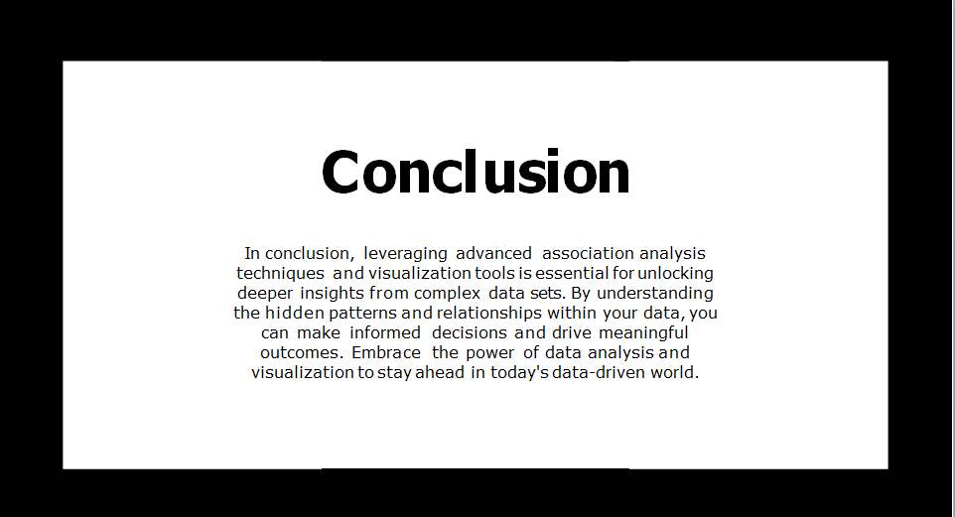





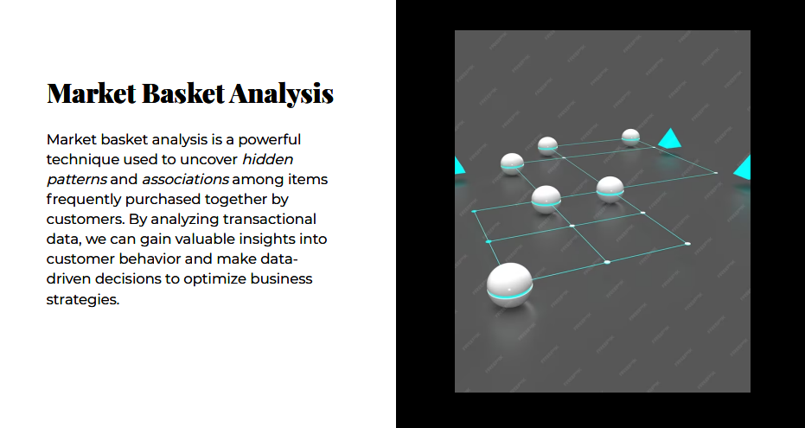

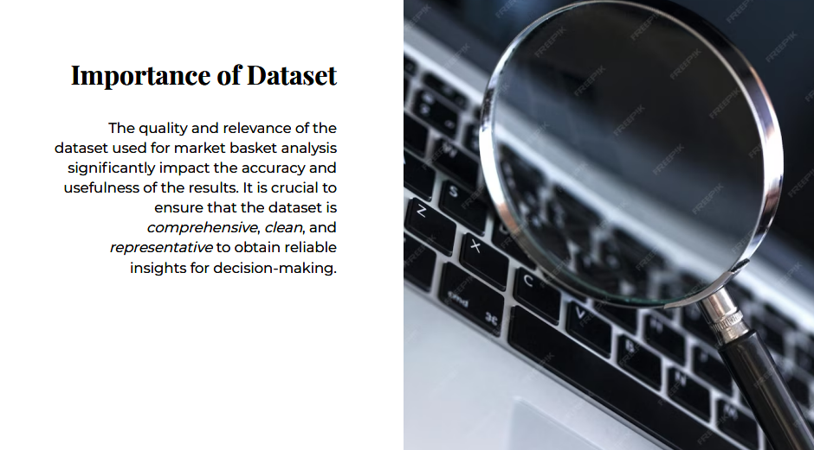

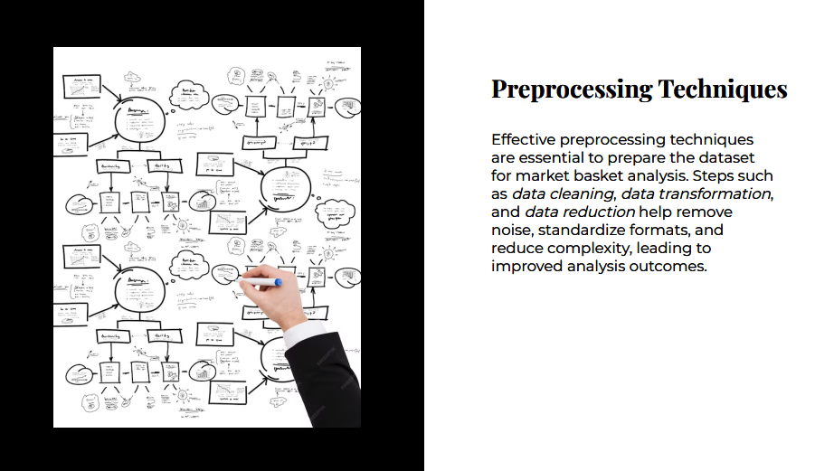

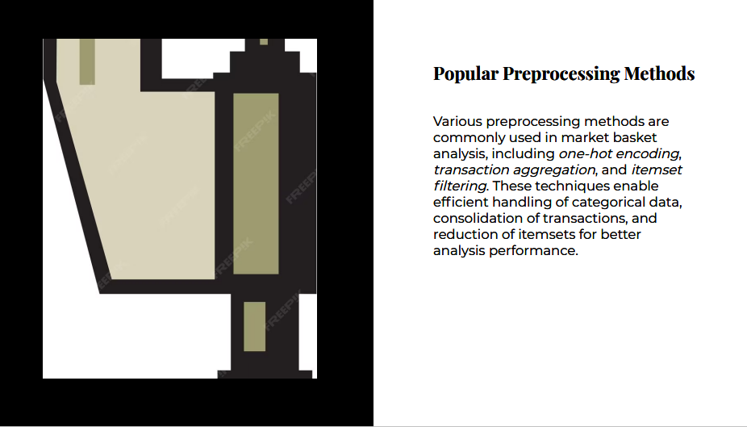

**Objectives**

**Check data quality.**

**Use exploratory data analysis to derive insights on product performance.**

**Apply association-rule-mining to discover opportunities for cross-selling.**

import pandas as pd

import matplotlib as mpl

import seaborn as sns

from matplotlib.axes import Axes

sns.set_palette("autumn")

mpl.rc("axes", titlesize=18, titlepad=15, titleweight=500)

mpl.rc("axes.spines", right=False, top=False)

mpl.rc("figure", figsize=(10, 5.5))

mpl.rc("font", family="serif", size=10)

def annotate_column_chart(ax: Axes) -> Axes:

*"""Add annotations to a column chart.*

for p **in** ax.patches:

p.set_width(0.7)

ax.annotate(f"**{**p.get_height()**:**,**}**", ha="center",

xy=(p.get_x() + p.get_width() / 2, p.get_height() * 1.01))

return ax

data = pd.read_csv(

header=None,

names=[f"item_**{**idx**}**" for idx **in** range(1, 21)]

)

print(

)

data.head()

There were a total of 7,501 transactions, each containing between 1 and 20 items.

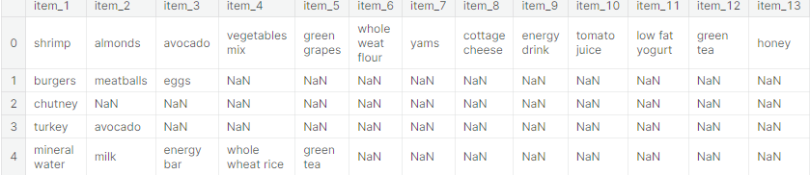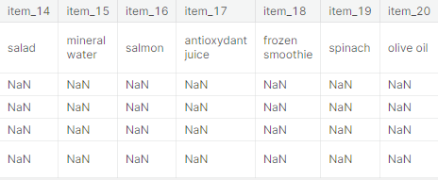

# 2. Data Cleaning

**One instance of the item "asparagus" contains leading whitespace. Other than that, the data looks fine.**

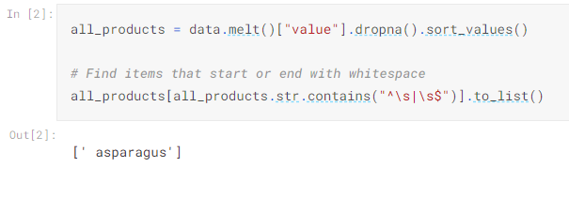

# 3. Exploratory Data Analysis

## 3.1 Best-selling products

**Assuming that only one unit of each item was bought in each transaction, mineral water is the most purchased product.**

**The top selling products are primarily food-stuff, but that's not at all surprising.**

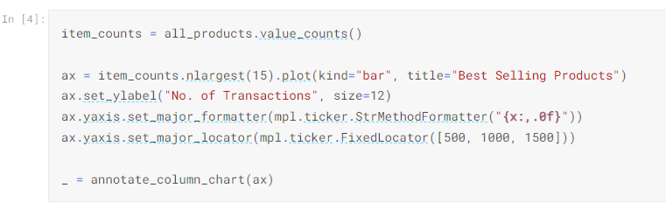

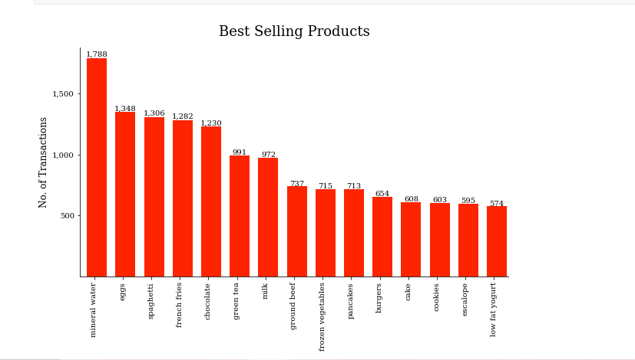

## 3.2 Worst performing products

**Assuming that only one unit of each item was bought in each transaction, water spray is sold the least.**

**It is quite unusual that the tea, chocolate bread and sandwiches are doing badly. This is worth investigating. Assuming this sample adequately captures the actual situation, then these products should probably be reviewed.**

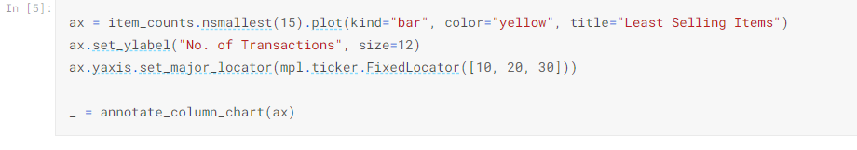

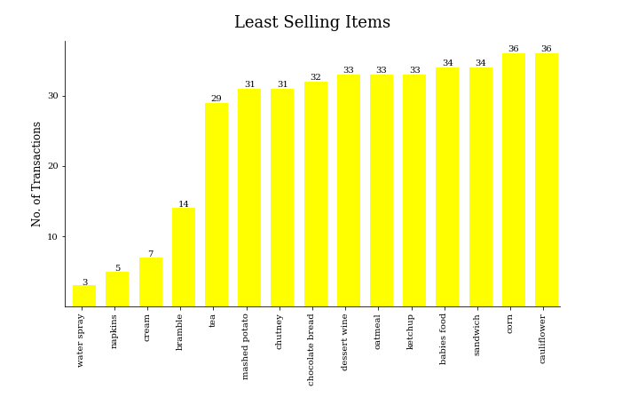

## 3.3 Distribution of Basket sizes

**The average basket-size was about 4 items. The largest transaction consisted of 20 items, and the smallest had just one.**

**Majority of the transactions involved a single item**.

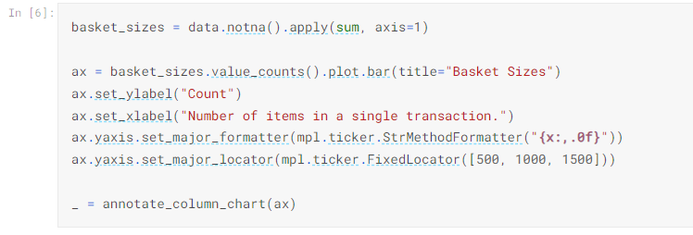

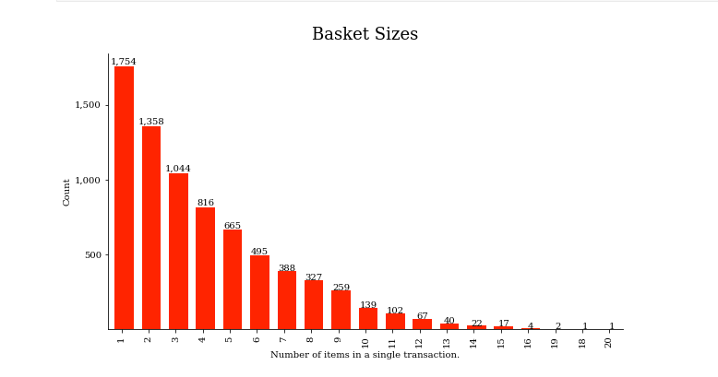

## 3.4 What's in the largest transactions?

**We'll consider transactions having more than 15 items (75% of maximum=20) as "large". There are 8 such transactions (16, 16, 16, 16, 18, 19, 19, 20).**

**Spaghetti and salmon are in 6 out of the eight largest transactions. Salmon's case is more striking, since we've already seen that spaghetti is the 3rd best seller. At face value, this might imply that customers who purchase a lot of items are more likely to buy salmon, so placing it next to the large trolleys/shopping-baskets might boost sales. But 8 out of 7501 cases doesn't inspire much confidence.**

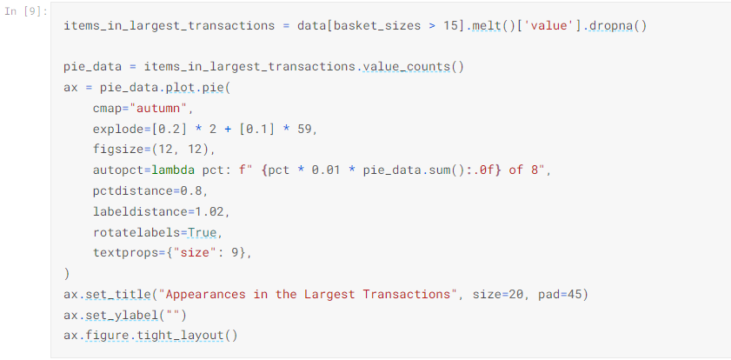

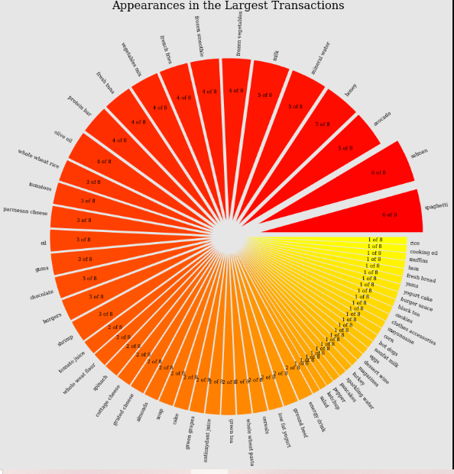

## 4.1 Preprocessing

**Data input to the efficient-apriori.apriori function is required as a sequence of "baskets" e.g. a list of tuples containing items.**

**In order to find item relationships, the baskets must include more than 1 item. We'll need to discard singleton transactions.**

# 

## 4.2 Association rules

**Potential opportunities for cross-selling are:**

* **frozen vegetables & spaghetti**
* **burgers & eggs**
* **ground beef & spaghetti**

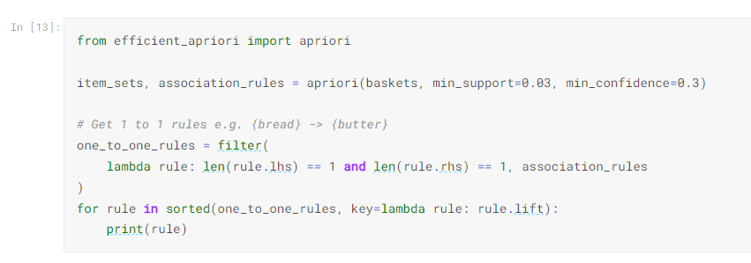

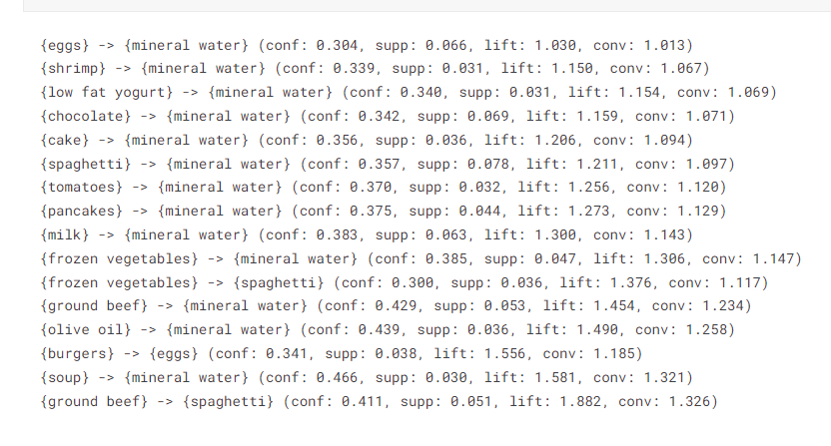

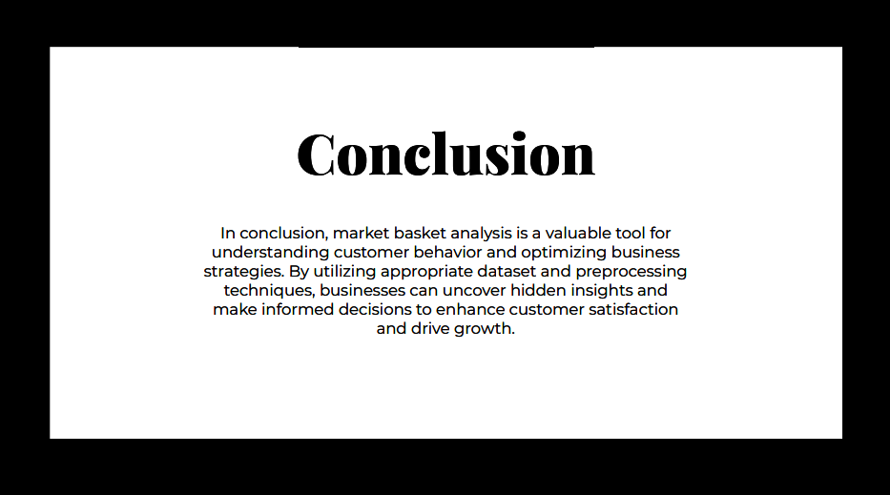

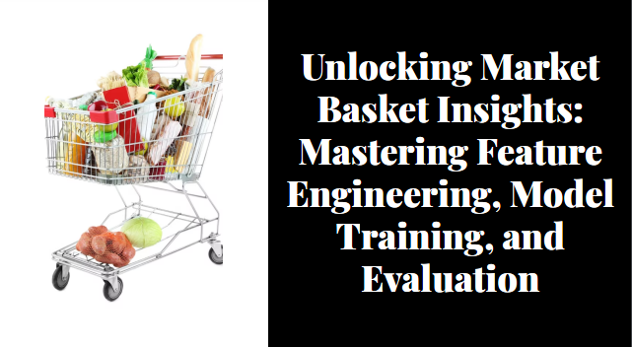



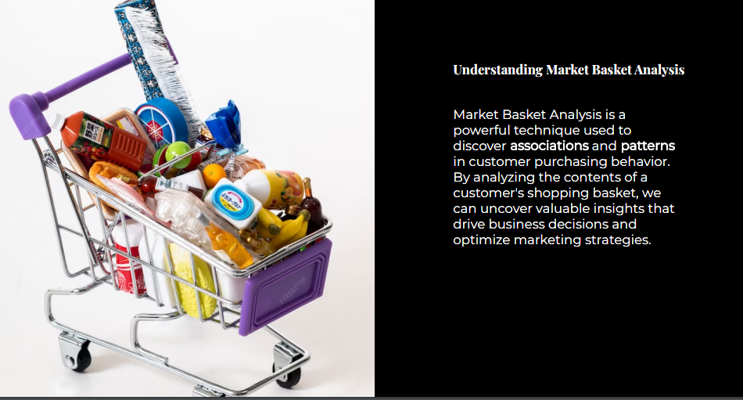







Load Dependencies and Configuration Settings

import os

import warnings

warnings.simplefilter(action = 'ignore', category=**FutureWarning**)

warnings.filterwarnings('ignore')

def ignore_warn(*args, **kwargs):

pass

warnings.warn = ignore_warn *#ignore annoying warning (from sklearn and seaborn)*

import pandas as pd

import datetime

import math

import numpy as np

import matplotlib.pyplot as plt

import matplotlib.mlab as mlab

import matplotlib.cm as cm

%matplotlib inline

from pandasql import sqldf

pysqldf = lambda q: sqldf(q, globals())

import seaborn as sns

sns.set(style="ticks", color_codes=True, font_scale=1.5)

color = sns.color_palette()

sns.set_style('darkgrid')

from mpl_toolkits.mplot3d import Axes3D

import plotly as py

import plotly.graph_objs as go

py.offline.init_notebook_mode()

from scipy import stats

from scipy.stats import skew, norm, probplot, boxcox

from sklearn import preprocessing

import math

from sklearn.cluster import KMeans

from sklearn.metrics import silhouette_samples, silhouette_score

import Orange

from Orange.data import Domain, DiscreteVariable, ContinuousVariable

from orangecontrib.associate.fpgrowth import *

## Exploratory Data Analysis (EDA)

def rstr(df, pred=None):

obs = df.shape[0]

types = df.dtypes

counts = df.apply(lambda x: x.count())

uniques = df.apply(lambda x: [x.unique()])

nulls = df.apply(lambda x: x.isnull().sum())

distincts = df.apply(lambda x: x.unique().shape[0])

missing_ration = (df.isnull().sum()/ obs) * 100

skewness = df.skew()

kurtosis = df.kurt()

print('Data shape:', df.shape)

if pred **is** None:

cols = ['types', 'counts', 'distincts', 'nulls', 'missing ration', 'uniques', 'skewness', 'kurtosis']

str = pd.concat([types, counts, distincts, nulls, missing_ration, uniques, skewness, kurtosis], axis = 1, sort=True)

else:

corr = df.corr()[pred]

str = pd.concat([types, counts, distincts, nulls, missing_ration, uniques, skewness, kurtosis, corr], axis = 1, sort=True)

corr_col = 'corr ' + pred

cols = ['types', 'counts', 'distincts', 'nulls', 'missing ration', 'uniques', 'skewness', 'kurtosis', corr_col ]

str.columns = cols

dtypes = str.types.value_counts()

print('___________________________**\n**Data types:**\n**',str.types.value_counts())

print('___________________________')

return str

details = rstr(cs_df)

display(details.sort_values(by='missing ration', ascending=False))

Data shape: (541909, 8)

___________________________

Data types:

object 4

float64 2

datetime64[ns] 1

int64 1

Name: types, dtype: int64

___________________________

print('Check if we had negative quantity and prices at same register:',

'No' if cs_df[(cs_df.Quantity<0) & (cs_df.UnitPrice<0)].shape[0] == 0 else 'Yes', '**\n**')

print('Check how many register we have where quantity is negative',

'and prices is 0 or vice-versa:',

cs_df[(cs_df.Quantity<=0) & (cs_df.UnitPrice<=0)].shape[0])

print('**\n**What is the customer ID of the registers above:',

cs_df.loc[(cs_df.Quantity<=0) & (cs_df.UnitPrice<=0),

['CustomerID']].CustomerID.unique())

print('**\n**% Negative Quantity: **{:3.2%}**'.format(cs_df[(cs_df.Quantity<0)].shape[0]/cs_df.shape[0]))

print('**\n**All register with negative quantity has Invoice start with:',

cs_df.loc[(cs_df.Quantity<0) & ~(cs_df.CustomerID.isnull()), 'InvoiceNo'].apply(lambda x: x[0]).unique())

print('**\n**See an example of negative quantity and others related records:')

display(cs_df[(cs_df.CustomerID==12472) & (cs_df.StockCode==22244)])

Check if we had negative quantity and prices at same register: No

Check how many register we have where quantity is negative and prices is 0 or vice-versa: 1336

What is the customer ID of the registers above: [nan]

% Negative Quantity: 1.96%

All register with negative quantity has Invoice start with: ['C']

print('Check register with UnitPrice negative:')

display(cs_df[(cs_df.UnitPrice<0)])

print("Sales records with Customer ID and zero in Unit Price:",cs_df[(cs_df.UnitPrice==0) & ~(cs_df.CustomerID.isnull())].shape[0])

cs_df[(cs_df.UnitPrice==0) & ~(cs_df.CustomerID.isnull())]

*# Remove register withou CustomerID*

cs_df = cs_df[~(cs_df.CustomerID.isnull())]

*# Remove negative or return transactions*

cs_df = cs_df[~(cs_df.Quantity<0)]

cs_df = cs_df[cs_df.UnitPrice>0]

details = rstr(cs_df)

display(details.sort_values(by='distincts', ascending=False))

Data shape: (397884, 8)

___________________________

Data types:

object 4

float64 2

datetime64[ns] 1

int64 1

Name: types, dtype: int64

cat_des_df = cs_df.groupby(["StockCode","Description"]).count().reset_index()

display(cat_des_df.StockCode.value_counts()[cat_des_df.StockCode.value_counts()>1].reset_index().head())

cs_df[cs_df['StockCode'] == cat_des_df.StockCode.value_counts()[cat_des_df.StockCode.value_counts()>1]

.reset_index()['index'][4]]['Description'].unique()

unique_desc = cs_df[["StockCode", "Description"]].groupby(by=["StockCode"]).\

apply(pd.DataFrame.mode).reset_index(drop=True)

q = '''

select df.InvoiceNo, df.StockCode, un.Description, df.Quantity, df.InvoiceDate,

df.UnitPrice, df.CustomerID, df.Country

from cs_df as df INNER JOIN

unique_desc as un on df.StockCode = un.StockCode

'''

cs_df = pysqldf(q)

In [11]:

linkcode

cs_df.InvoiceDate = pd.to_datetime(cs_df.InvoiceDate)

cs_df['amount'] = cs_df.Quantity*cs_df.UnitPrice

cs_df.CustomerID = cs_df.CustomerID.astype('Int64')

details = rstr(cs_df)

display(details.sort_values(by='distincts', ascending=False))

Data shape: (397884, 9)

___________________________

Data types:

object 3

int64 3

float64 2

datetime64[ns] 1

Name: types, dtype: int64

___________________________

fig = plt.figure(figsize=(25, 7))

f1 = fig.add_subplot(121)

g = cs_df.groupby(["Country"]).amount.sum().sort_values(ascending = False).plot(kind='bar', title='Amount Sales by Country')

cs_df['Internal'] = cs_df.Country.apply(lambda x: 'Yes' if x=='United Kingdom' else 'No' )

f2 = fig.add_subplot(122)

market = cs_df.groupby(["Internal"]).amount.sum().sort_values(ascending = False)

g = plt.pie(market, labels=market.index, autopct='**%1.1f%%**', shadow=True, startangle=90)

plt.title('Internal Market')

plt.show()

fig = plt.figure(figsize=(25, 7))

PercentSales = np.round((cs_df.groupby(["CustomerID"]).amount.sum().\

sort_values(ascending = False)[:51].sum()/cs_df.groupby(["CustomerID"]).\

amount.sum().sort_values(ascending = False).sum()) * 100, 2)

g = cs_df.groupby(["CustomerID"]).amount.sum().sort_values(ascending = False)[:51].\

plot(kind='bar', title='Top Customers: **{:3.2f}**% Sales Amount'.format(PercentSales))

fig = plt.figure(figsize=(25, 7))

f1 = fig.add_subplot(121)

PercentSales = np.round((cs_df.groupby(["CustomerID"]).amount.sum().\

sort_values(ascending = False)[:10].sum()/cs_df.groupby(["CustomerID"]).\

amount.sum().sort_values(ascending = False).sum()) * 100, 2)

g = cs_df.groupby(["CustomerID"]).amount.sum().sort_values(ascending = Fals

e)[:10]\

.plot(kind='bar', title='Top 10 Customers: **{:3.2f}**% Sales Amont'.format(PercentSales))

f1 = fig.add_subplot(122)

PercentSales = np.round((cs_df.groupby(["CustomerID"]).amount.count().\

sort_values(ascending = False)[:10].sum()/cs_df.groupby(["CustomerID"]).\

amount.count().sort_values(ascending = False).sum()) * 100, 2)

g = cs_df.groupby(["CustomerID"]).amount.count().sort_values(ascending = False)[:10].\

plot(kind='bar', title='Top 10 Customers: **{:3.2f}% E**vent Sales'.format(PercentSales))

AmoutSum = cs_df.groupby(["Description"]).amount.sum().sort_values(ascending = False)

inv = cs_df[["Description", "InvoiceNo"]].groupby(["Description"]).InvoiceNo.unique().\

agg(np.size).sort_values(ascending = False)

fig = plt.figure(figsize=(25, 7))

f1 = fig.add_subplot(121)

Top10 = list(AmoutSum[:10].index)

PercentSales = np.round((AmoutSum[Top10].sum()/AmoutSum.sum()) * 100, 2)

PercentEvents = np.round((inv[Top10].sum()/inv.sum()) * 100, 2)

g = AmoutSum[Top10].\

plot(kind='bar', title='Top 10 Products in Sales Amount: **{:3.2f}% o**f Amount and **{:3.2f}% o**f Events'.\

format(PercentSales, PercentEvents))

f1 = fig.add_subplot(122)

Top10Ev = list(inv[:10].index)

PercentSales = np.round((AmoutSum[Top10Ev].sum()/AmoutSum.sum()) * 100, 2)

PercentEvents = np.round((inv[Top10Ev].sum()/inv.sum()) * 100, 2)

g = inv[Top10Ev].\

plot(kind='bar', title='Events of top 10 most sold products: **{:3.2f}% o**f Amount and **{:3.2f}% o**f Events'.\

format(PercentSales, PercentEvents))

fig = plt.figure(figsize=(25, 7))

Top15ev = list(inv[:15].index)

PercentSales = np.round((AmoutSum[Top15ev].sum()/AmoutSum.sum()) * 100, 2)

PercentEvents = np.round((inv[Top15ev].sum()/inv.sum()) * 100, 2)

g = AmoutSum[Top15ev].sort_values(ascending = False).\

plot(kind='bar',

title='Sales Amount of top 15 most sold products: **{:3.2f}% o**f Amount and **{:3.2f}% o**f Events'.\

format(PercentSales, PercentEvents))

fig = plt.figure(figsize=(25, 7))

Top50 = list(AmoutSum[:50].index)

PercentSales = np.round((AmoutSum[Top50].sum()/AmoutSum.sum()) * 100, 2)

PercentEvents = np.round((inv[Top50].sum()/inv.sum()) * 100, 2)

g = AmoutSum[Top50].\

plot(kind='bar',

title='Top 50 Products in Sales Amount: **{:3.2f}% o**f Amount and **{:3.2f}% o**f Events'.\

format(PercentSales, PercentEvents))

fig = plt.figure(figsize=(25, 7))

Top50Ev = list(inv[:50].index)

PercentSales = np.round((AmoutSum[Top50Ev].sum()/AmoutSum.sum()) * 100, 2)

PercentEvents = np.round((inv[Top50Ev].sum()/inv.sum()) * 100, 2)

g = inv[Top50Ev].\

plot(kind='bar', title='Top 50 most sold products: **{:3.2f}% o**f Amount and **{:3.2f}% o**f Events'.\

format(PercentSales, PercentEvents))

## Customer Segmentation:

refrence_date = cs_df.InvoiceDate.max() + datetime.timedelta(days = 1)

print('Reference Date:', refrence_date)

cs_df['days_since_last_purchase'] = (refrence_date - cs_df.InvoiceDate).astype('timedelta64[D]')

customer_history_df = cs_df[['CustomerID', 'days_since_last_purchase']].groupby("CustomerID").min().reset_index()

customer_history_df.rename(columns={'days_since_last_purchase':'recency'}, inplace=True)

customer_history_df.describe().transpose()

def QQ_plot(data, measure):

fig = plt.figure(figsize=(20,7))

*#Get the fitted parameters used by the function*

(mu, sigma) = norm.fit(data)

*#Kernel Density plot*

fig1 = fig.add_subplot(121)

sns.distplot(data, fit=norm)

fig1.set_title(measure + ' Distribution ( mu = **{:.2f}** and sigma = **{:.2f}** )'.format(mu, sigma), loc='center')

fig1.set_xlabel(measure)

fig1.set_ylabel('Frequency')

*#QQ plot*

fig2 = fig.add_subplot(122)

res = probplot(data, plot=fig2)

fig2.set_title(measure + ' Probability Plot (skewness: **{:.6f}** and kurtosis: **{:.6f}** )'.format(data.skew(), data.kurt()), loc='center')

plt.tight_layout()

plt.show()

QQ_plot(customer_history_df.recency, 'Recency')

#### Frequency:-

customer_freq = (cs_df[['CustomerID', 'InvoiceNo']].groupby(["CustomerID", 'InvoiceNo']).count().reset_index()).\

groupby(["CustomerID"]).count().reset_index()

customer_freq.rename(columns={'InvoiceNo':'frequency'},inplace=True)

customer_history_df = customer_history_df.merge(customer_freq)

QQ_plot(customer_history_df.frequency, 'Frequency')

#### Monetary Value:-

customer_monetary_val = cs_df[['CustomerID', 'amount']].groupby("CustomerID").sum().reset_index()

customer_history_df = customer_history_df.merge(customer_monetary_val)

QQ_plot(customer_history_df.amount, 'Amount')

### Data Preprocessing:-

customer_history_df['recency_log'] = customer_history_df['recency'].apply(math.log)

customer_history_df['frequency_log'] = customer_history_df['frequency'].apply(math.log)

customer_history_df['amount_log'] = customer_history_df['amount'].apply(math.log)

feature_vector = ['amount_log', 'recency_log','frequency_log']

X_subset = customer_history_df[feature_vector] *#.as_matrix()*

scaler = preprocessing.StandardScaler().fit(X_subset)

X_scaled = scaler.transform(X_subset)

pd.DataFrame(X_scaled, columns=X_subset.columns).describe().T

fig = plt.figure(figsize=(20,14))

f1 = fig.add_subplot(221); sns.regplot(x='recency', y='amount', data=customer_history_df)

f1 = fig.add_subplot(222); sns.regplot(x='frequency', y='amount', data=customer_history_df)

f1 = fig.add_subplot(223); sns.regplot(x='recency_log', y='amount_log', data=customer_history_df)

f1 = fig.add_subplot(224); sns.regplot(x='frequency_log', y='amount_log', data=customer_history_df)

fig = plt.figure(figsize=(15, 10))

ax = fig.add_subplot(111, projection='3d')

xs =customer_history_df.recency_log

ys = customer_history_df.frequency_log

zs = customer_history_df.amount_log

ax.scatter(xs, ys, zs, s=5)

ax.set_xlabel('Recency')

ax.set_ylabel('Frequency')

ax.set_zlabel('Monetary')

plt.show()

#### The Elbow Method

cl = 50

corte = 0.1

anterior = 100000000000000

cost = []

K_best = cl

for k **in** range (1, cl+1):

*# Create a kmeans model on our data, using k clusters. random_state helps ensure that the algorithm returns the same results each time.*

model = KMeans(

n_clusters=k,

init='k-means++', *#'random',*

n_init=10,

max_iter=300,

tol=1e-04,

random_state=101)

model = model.fit(X_scaled)

labels = model.labels_

*# Sum of distances of samples to their closest cluster center*

interia = model.inertia_

if (K_best == cl) **and** (((anterior - interia)/anterior) < corte): K_best = k - 1

cost.append(interia)

anterior = interia

plt.figure(figsize=(8, 6))

plt.scatter(range (1, cl+1), cost, c='red')

plt.show()

*# Create a kmeans model with the best K.*

print('The best K sugest: ',K_best)

model = KMeans(n_clusters=K_best, init='k-means++', n_init=10,max_iter=300, tol=1e-04, random_state=101)

model = model.fit(X_scaled)

*# These are our fitted labels for clusters -- the first cluster has label 0, and the second has label 1.*

labels = model.labels_

*# And we'll visualize it:*

*#plt.scatter(X_scaled[:,0], X_scaled[:,1], c=model.labels_.astype(float))*

fig = plt.figure(figsize=(20,5))

ax = fig.add_subplot(121)

plt.scatter(x = X_scaled[:,1], y = X_scaled[:,0], c=model.labels_.astype(float))

ax.set_xlabel(feature_vector[1])

ax.set_ylabel(feature_vector[0])

ax = fig.add_subplot(122)

plt.scatter(x = X_scaled[:,2], y = X_scaled[:,0], c=model.labels_.astype(float))

ax.set_xlabel(feature_vector[2])

ax.set_ylabel(feature_vector[0])

plt.show()

#### Silhouette analysis on K-Means clustering

cluster_centers = dict()

for n_clusters **in** range(3,K_best+1,2):

fig, (ax1, ax2, ax3) = plt.subplots(1, 3)

fig.set_size_inches(25, 7)

ax1.set_xlim([-0.1, 1])

ax1.set_ylim([0, len(X_scaled) + (n_clusters + 1) * 10])

clusterer = KMeans(n_clusters=n_clusters, init='k-means++', n_init=10,max_iter=300, tol=1e-04, random_state=101)

cluster_labels = clusterer.fit_predict(X_scaled)

silhouette_avg = silhouette_score(X = X_scaled, labels = cluster_labels)

cluster_centers.update({n_clusters :{'cluster_center':clusterer.cluster_centers_,

'silhouette_score':silhouette_avg,

labels':cluster_labels}

})

sample_silhouette_values = silhouette_samples(X = X_scaled, labels = cluster_labels)

y_lower = 10

for i **in** range(n_clusters):

ith_cluster_silhouette_values = sample_silhouette_values[cluster_labels == i]

ith_cluster_silhouette_values.sort()

size_cluster_i = ith_cluster_silhouette_values.shape[0]

y_upper = y_lower + size_cluster_i

color = cm.Spectral(float(i) / n_clusters)

ax1.fill_betweenx(np.arange(y_lower, y_upper),

0, ith_cluster_silhouette_values,

facecolor=color, edgecolor=color, alpha=0.7)

ax1.text(-0.05, y_lower + 0.5 * size_cluster_i, str(i))

y_lower = y_upper + 10 *# 10 for the 0 samples*

ax1.set_title("The silhouette plot for the various clusters")

ax1.set_xlabel("The silhouette coefficient values")

ax1.set_ylabel("Cluster label")

ax1.axvline(x=silhouette_avg, color="red", linestyle="--")

ax1.set_yticks([])

ax1.set_xticks([-0.1, 0, 0.1, 0.2, 0.3, 0.4, 0.5, 0.6, 0.7, 0.8, 0.9, 1])

colors = cm.Spectral(cluster_labels.astype(float) / n_clusters)

centers = clusterer.cluster_centers_

y = 0

x = 1

ax2.scatter(X_scaled[:, x], X_scaled[:, y], marker='.', s=30, lw=0, alpha=0.7, c=colors, edgecolor='k')

ax2.scatter(centers[:, x], centers[:, y], marker='o', c="white", alpha=

1, s=200, edgecolor='k')

for i, c **in** enumerate(centers):

ax2.scatter(c[x], c[y], marker='$**%d**$' % i, alpha=1, s=50, edgecolor='k')

ax2.set_title("**{}** Clustered data".format(n_clusters))

ax2.set_xlabel(feature_vector[x])

ax2.set_ylabel(feature_vector[y])

x = 2

ax3.scatter(X_scaled[:, x], X_scaled[:, y], marker='.', s=30, lw=0, alpha=0.7, c=colors, edgecolor='k')

ax3.scatter(centers[:, x], centers[:, y], marker='o', c="white", alpha=1, s=200, edgecolor='k')

for i, c **in** enumerate(centers):

ax3.scatter(c[x], c[y], marker='$**%d**$' % i, alpha=1, s=50, edgecolor='k')

ax3.set_title("Silhouette score: **{:1.2f}**".format(cluster_centers[n_clus

ters]['silhouette_score']))

ax3.set_xlabel(feature_vector[x])

ax3.set_ylabel(feature_vector[y])

plt.suptitle(("Silhouette analysis for KMeans clustering on sample data with n_clusters = **%d**" % n_clusters),

fontsize=14, fontweight='bold')

plt.show()

#### Clusters Center:

features = ['amount', 'recency', 'frequency']

for i **in** range(3,K_best+1,2):

print("for **{}** clusters the silhouette score is **{:1.2f}**".format(i, cluster_centers[i]['silhouette_score']))

print("Centers of each cluster:")

cent_transformed = scaler.inverse_transform(cluster_centers[i]['cluster_center'])

print(pd.DataFrame(np.exp(cent_transformed),columns=features))

print('-'*50)

for 3 clusters the silhouette score is 0.34

Centers of each cluster:

amount recency frequency

0 261.952265 116.604917 1.190876

1 3967.994380 7.236580 10.044493

2 1006.914317 33.819966 3.152227

--------------------------------------------------

for 5 clusters the silhouette score is 0.31

Centers of each cluster:

amount recency frequency

0 213.876290 159.060239 1.088129

1 5708.668108 4.285608 13.677542

2 1929.872406 22.442129 5.413014

3 372.314665 14.590855 1.665686

4 863.093356 100.092666 2.395562

--------------------------------------------------

for 7 clusters the silhouette score is 0.31

Centers of each cluster:

amount recency frequency

0 809.713152 107.590047 2.277095

1 2115.751105 4.436558 6.395614

2 239.805507 36.372861 1.132543

3 667.345658 13.698858 2.663541

4 205.016462 225.462781 1.082459

5 2414.804796 38.026754 6.003854

6 10182.351681 4.961015 20.687947

--------------------------------------------------

customer_history_df['clusters_3'] = cluster_centers[3]['labels']

customer_history_df['clusters_5'] = cluster_centers[5]['labels']

customer_history_df['clusters_7'] = cluster_centers[7]['labels']

display(customer_history_df.head())

fig = plt.figure(figsize=(20,7))

f1 = fig.add_subplot(131)

market = customer_history_df.clusters_3.value_counts()

g = plt.pie(market, labels=market.index, autopct='**%1.1f%%**', shadow=True, startangle=90)

plt.title('3 Clusters')

f1 = fig.add_subplot(132)

market = customer_history_df.clusters_5.value_counts()

g = plt.pie(market, labels=market.index, autopct='**%1.1f%%**', shadow=True, startangle=90)

plt.title('5 Clusters')

f1 = fig.add_subplot(133)

market = customer_history_df.clusters_7.value_counts()

g = plt.pie(market, labels=market.index, autopct='**%1.1f%%**', shad

g = plt.pie(market, labels=market.index, autopct='**%1.1f%%**', shadow=True, startangle=90)

plt.title('7 Clusters')

plt.show()

x_data = ['Cluster 0', 'Cluster 1','Cluster 2','Cluster 3','Cluster 4', 'Cluster 5', 'Cluster 6']

colors = ['rgba(93, 164, 214, 0.5)', 'rgba(255, 144, 14, 0.5)', 'rgba(44, 160, 101, 0.5)', 'rgba(255, 65, 54, 0.5)',

'rgba(22, 80, 57, 0.5)', 'rgba(127, 65, 14, 0.5)', 'rgba(207, 114, 255, 0.5)', 'rgba(127, 96, 0, 0.5)']

cutoff_quantile = 95

for n_clusters **in** range(3,K_best+1,2):

cl = 'clusters_' + str(n_clusters)

for fild **in** range(0, 3):

field_to_plot = features[fild]

y_data = list()

ymax = 0

for i **in** np.arange(0,n_clusters):

y0 = customer_history_df[customer_history_df[cl]==i][field_to_p

lot].values

y0 = y0[y0<np.percentile(y0, cutoff_quantile)]

if ymax < max(y0): ymax = max(y0)

y_data.insert(i, y0)

traces = []

for xd, yd, cls **in** zip(x_data[:n_clusters], y_data, colors[:n_clusters]):

traces.append(go.Box(y=yd, name=xd, boxpoints=False, jitter=0.5, whiskerwidth=0.2, fillcolor=cls,

marker=dict( size=1, ),

line=dict(width=1),

))

layout = go.Layout(

title='Difference in **{}** with **{}** Clusters and **{:1.2f}** Score'.\

format(field_to_plot, n_clusters, cluster_centers[n_clusters]['silhouette_score']),

yaxis=dict( autorange=True, showgrid=True, zeroline=True,

dtick = int(ymax/10),

gridcolor='black', gridwidth=0.1, zerolinecolor='rgb(255, 255, 255)', zerolinewidth=2, ),

margin=dict(l=40, r=30, b=50, t=50, ),

paper_bgcolor='white',

plot_bgcolor='white',

showlegend=False

)

fig = go.Figure(data=traces, layout=layout)

py.offline.iplot(fig)

